- Overview of the Game
A man, Vincent has been abused and traumatised by his parents till he had became insane. He came up with a plan and he knew his uncle will be coming on that day. One day, while his parents were asleep, he stabbed his dad, then the mom was awaken then she screamed and begged. Then she could not make it and he stabbed her in the corridor. Then the uncle came in time and he knocked him out and pour alcohol over him and makes the crime scene looks like is caused by his uncle. Then he called the police and now the uncle became the scapegoat. Vincent was sent to orphanage. After many years, he decided to create an escape room that resemble his childhood house torture the victims. He had been finding an easy target (victims that are easy to kidnapped such as with physical limitations like visually-impaired, no limbs). He made simple puzzles for difficult people to prove they were failures. One day, Vincent notices a man and went to find out this man, Nicholas has lv 2 autism. Vincent managed to kipnapped him and let him be the next player.

- Unique Selling Points
- Each puzzle has its backstory
- It has the elements of horror, mystery, and emotion
- Unique puzzles
c) Game loop
Explore the room → Find clues → Solve puzzle → Repeat until escape
- Gameplay Scope
- 4 puzzles that have meaning behind them
- 10 rooms
- House-like escape room
- Focus on solving puzzles
- Finding clues

Puzzle 1:
- The player needs to find the key in the location where he is at the start and put the key near the door

The clue “Key” is on the cabinet


The key is here


Puzzle 2:
- The player need to touch a gem on the floor in the master bedroom then the gem disappear

The clue “Gem” is on the wall
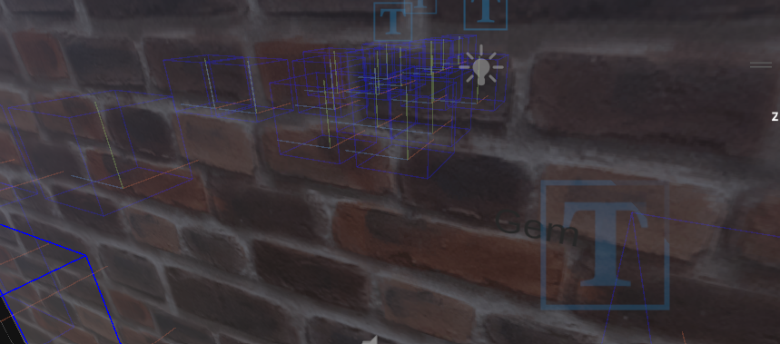

The gem is hidden here


Puzzle 3:
- The player need to click a button on a cabinet in the living room to shut the noise up

The clue “Button” is on the door the main door
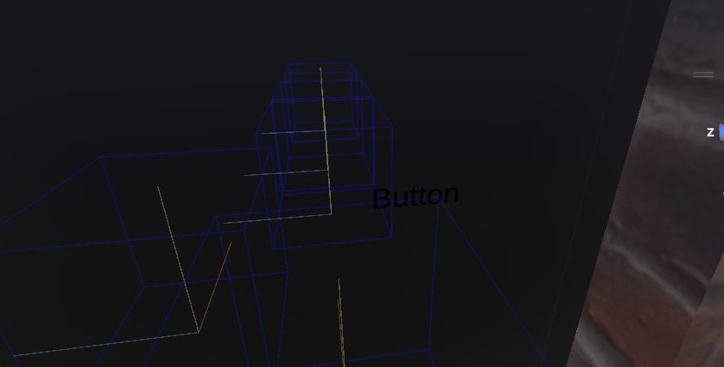

The tiny button on the cabinet to be press near the main door


Puzzle 4:
- The player needs to click the lamp on the table in the living room to off the light
The clue is on the tv “Lamp”
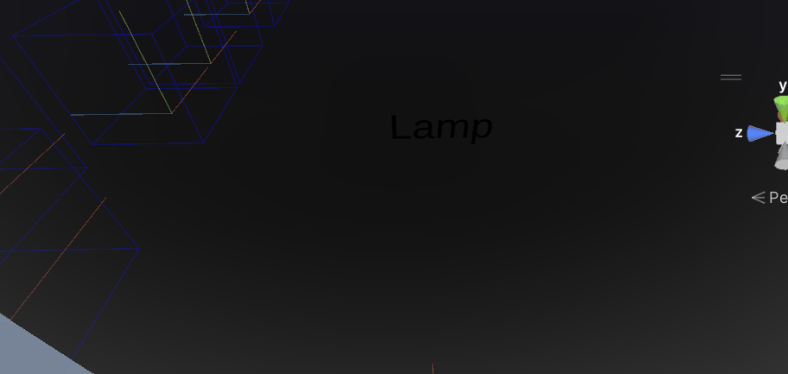

The lamp
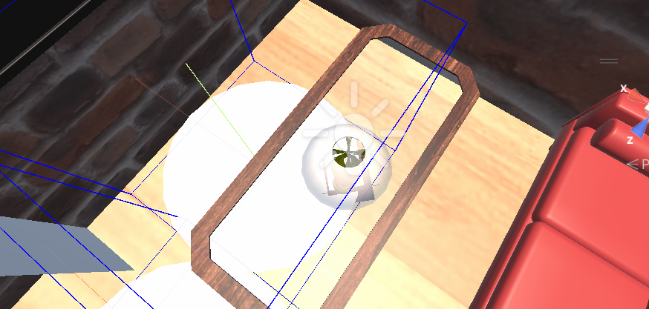

- Art Style
- Eerie

- Player Profiles Stories
- Name: Nicholas
- A lv 2 autistic victim who gets kidnapped
- Solve four puzzles to escape
- Milestone Schedule
- Week 4: Story + puzzle design
- Week 5: 3D model assets
- Week 6: AR coding
- Week 7: Puzzle testing
- Week 8: Art polish
- Week 9: Playtest
- Week 10: Fix bugs
- Week 11: Final polish

- Project Vitals (where applicable)
- Project title: AR Escape Room
- Platform: Unity + AR Foundation (for mobile AR)
- Objective: Create an AR escape room where the player solves four puzzles to escape
- Target audience: Teenagers and adults who like to play AR escape rooms
- Core feature:
-AR puzzle objects
-Interactive clues

AR Prototype
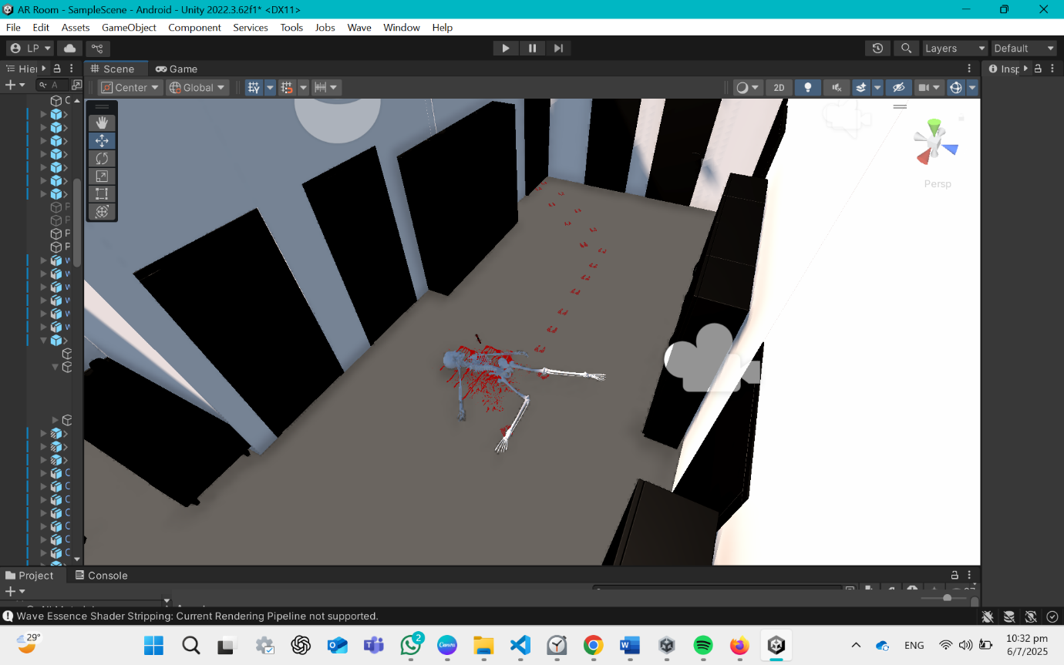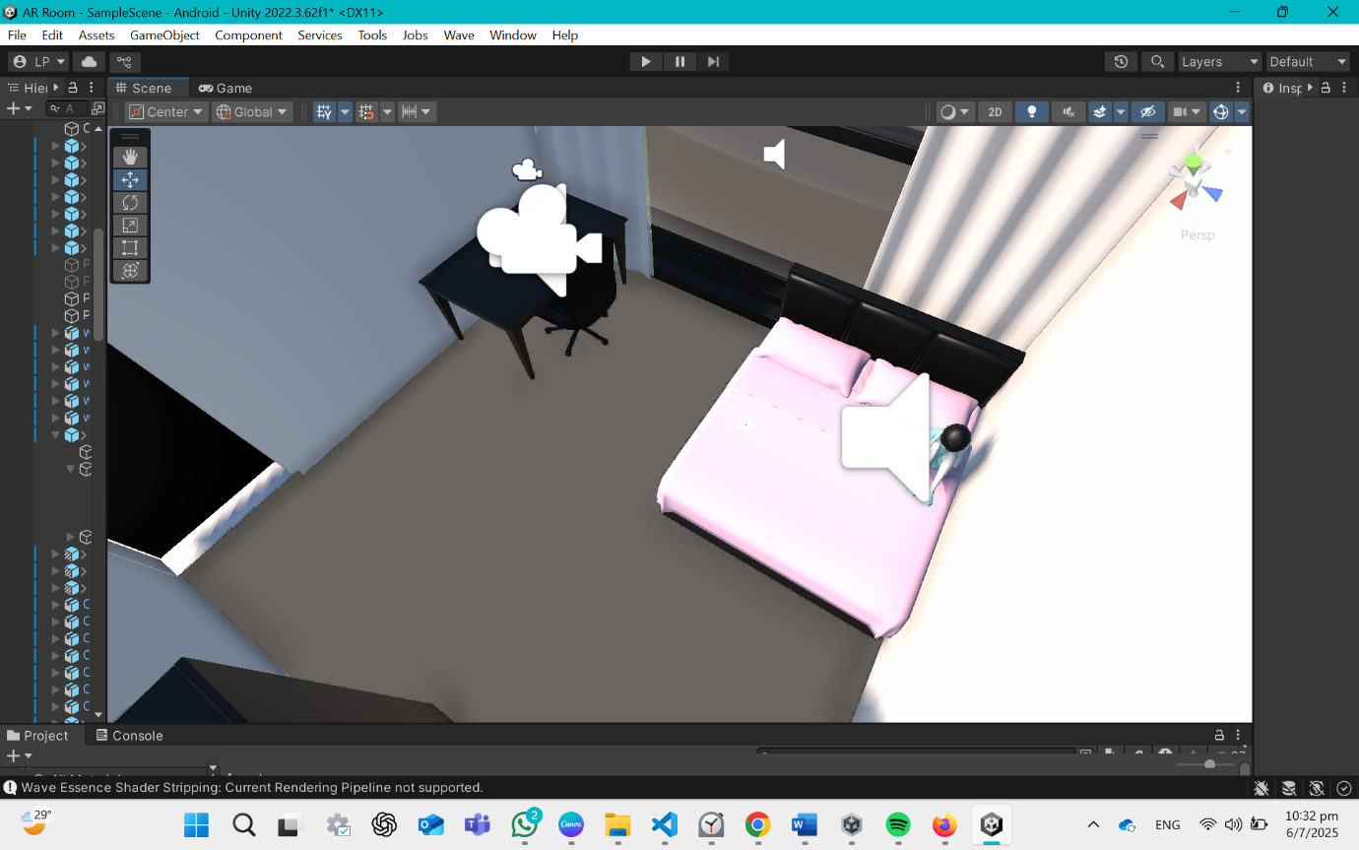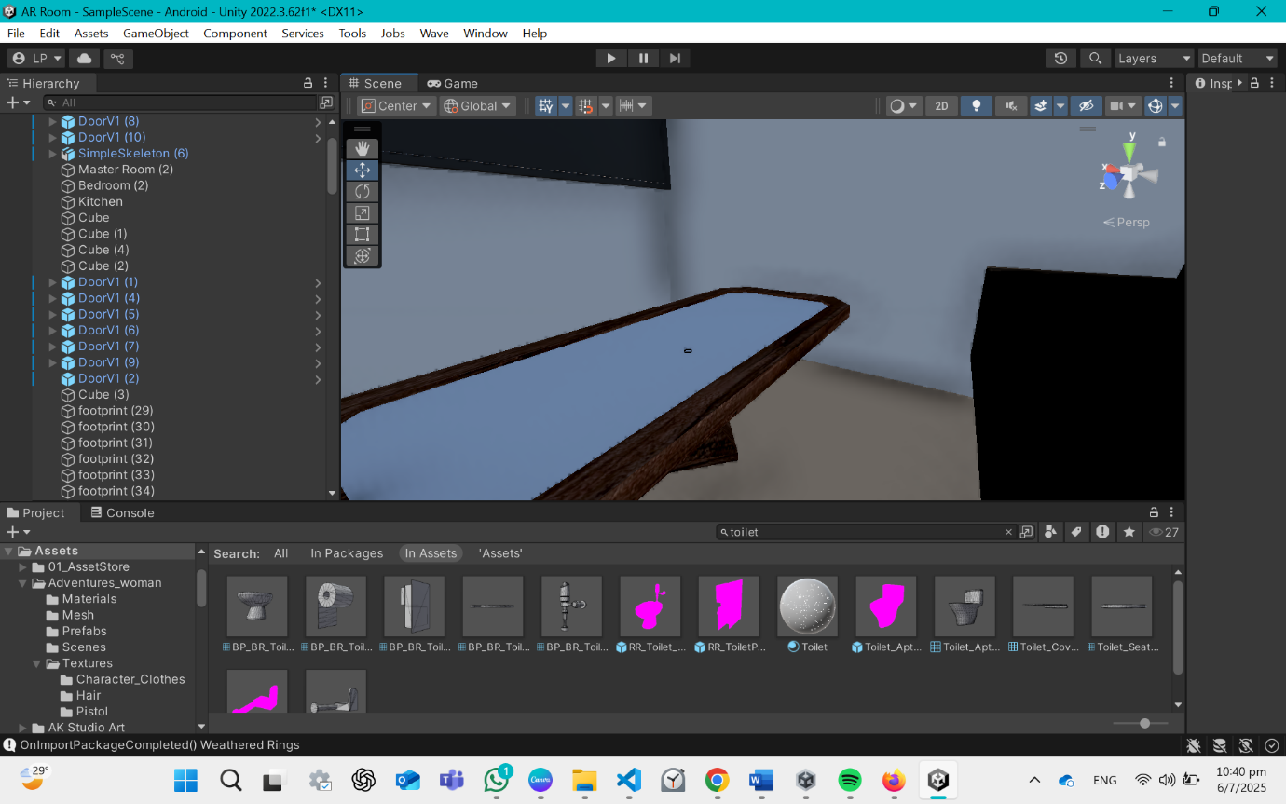
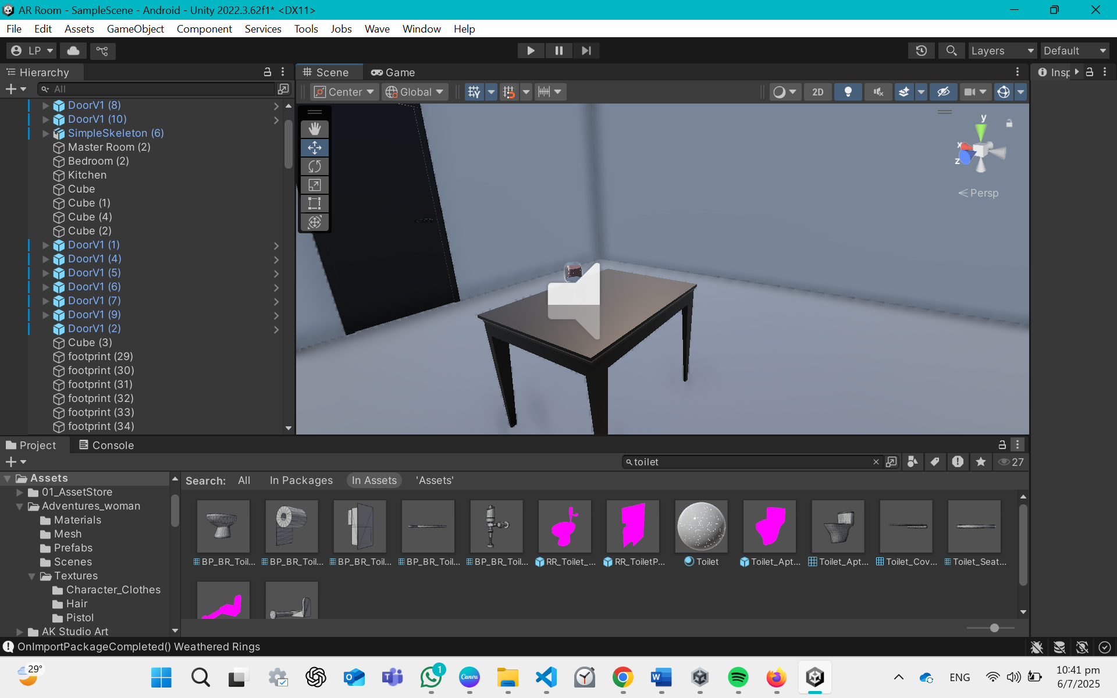

Actual product:
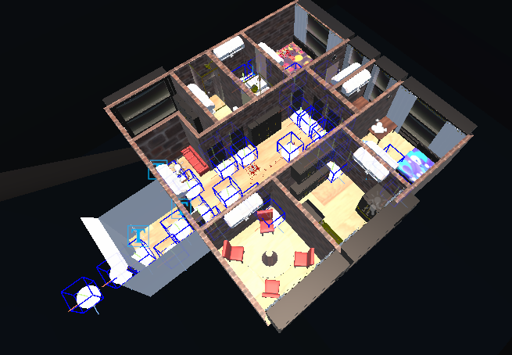

Why it is horror?
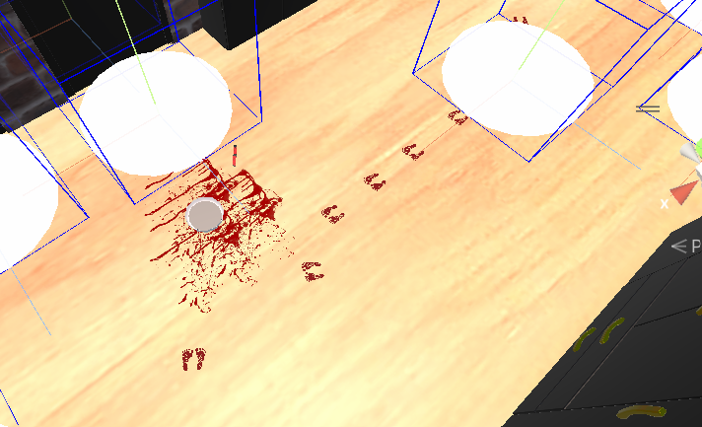
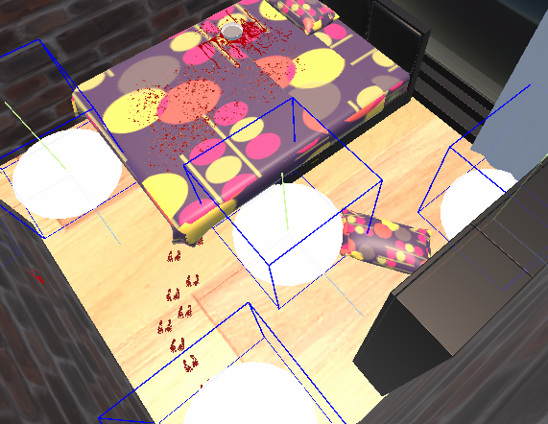

AND the screaming and crying in the background

OpenAI. (2023). ChatGPT (Mar 14 version) [Large language model]. https://chat.openai.com/chat

